In this assignment, you will build a model of a DNA molecule out of found objects.
- The model must be at least 8 nucleotides long. It must include the following:
- sugar-phosphate backbones (sides)
- 8 pairs of nucleotides, each made up of a sugar, phosphate and nitrogenous base
- correct complementary base pairs
- helical shape
- You must create a legend to your model, explaining what part of the DNA molecule each of the objects represents.
- What can you use? Anything you want that is not going to look or smell offensive or endanger anyone. I recommend using materials that you already have around your house or kitchen (cheerios, pieces of pasta, small tiles, pieces of wood, cut-up straws, beads, buttons, ribbon, candies, rolled up aluminium, etc). Do not build the whole model out of
LEGO or any other prefabricated system. It's OK if you decide to use four different colours of
LEGO blocks to represent the four different nitrogenous bases, but then you would not use
LEGO for anything else in the model (such as phosphate groups or sugar).
This diagram shows 4 pairs of nucleotides (8 in total). An example of a single nucleotide is shown in the rectangle. Each nucleotide is made up of a sugar, phosphate and a nitrogen base.
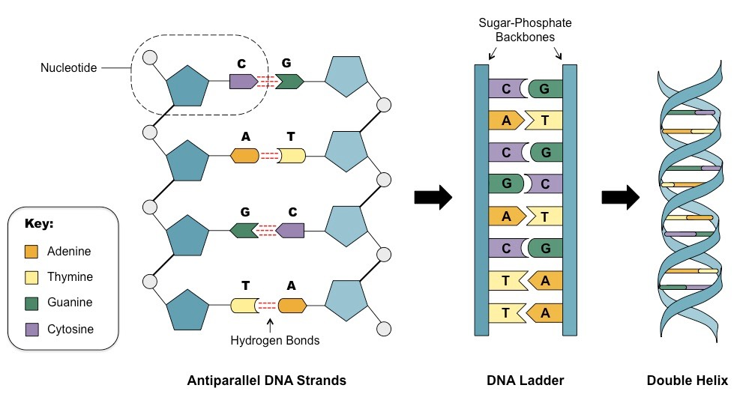

Note: Different glues work on different materials. Read what it says on the glue bottle. For example, white glue only works with natural materials like paper, wood, cotton, pasta and cheerios. If you're using plastic items, you need to use glue that is specifically made to bond with plastic. Otherwise it won't stick properly, and parts of your model will fall off on the way to school.
BRING ALL MATERIALS TO SCHOOL FOR Tuesday Feb 15th 2022.
Criteria
Accuracy – showing all of the parts of a DNA molecule in the correct places
Artistry – showing creativity in choice of materials and care in construction of the model and of the legend
What materials will I need?
- -
- -
- -
- -
- -
- -
- -
What will my DNA structure look like? (Draw an image of your structure and label what you will use to build each part)

