Cells Review!
What’s small?

How small is small?

What is the smallest living organism that you’ve ever seen?

Most people can only see objects that are _____________ or larger, that’s the thickness of a sheet of ________________!

In past centuries, it was common belief that _______________, ________________and even _______________, could be produced from _________________ material such as air and water. Aristotle, Greek philosopher, rejected the idea that life came from rain and thought life came from mud or rotting meat.
This idea was called ___________________ generation and was used to explain the magical appearance of maggots on decaying carcasses. This theory lasted for nearly 2000 years!
It wasn’t until 1668 when Francesco __________ determined that the maggots came from _______ laid by flies.
Redi created an experiment using two jars that contained _________. One jar was _____________ and the other was kept ______________.
The opened jar attracted flies and eventually __________________ appeared. The sealed jar remained unchanged.
The maggots eventually became __________ and Redi theory was proof.

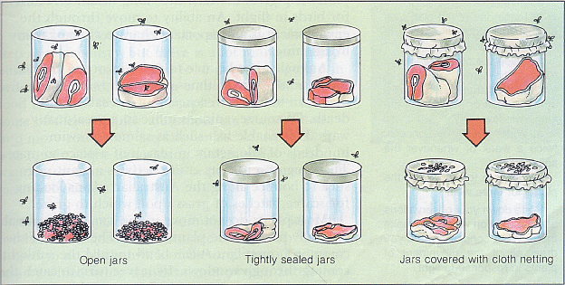

Although Redi helped defeat the theory of spontaneous generation for flies the theory still lingered for ______________________________.
Scientist John Needham(1713-1781) noticed that meat broth smelled putrid when left unsealed. He boiled the broth to kill any __________________ (microorganisms) but after a couple weeks the microbes ____________ ___________.
Despite Redi’s experiment and Needham’s __________________, many people still believed in spontaneous generation until Louis Pasteur, a French chemist, did a _________________experiment that confirmed that bacteria and other __________________________ organisms are carried in the air on dust particles and water vapour.
After Pasteur’s famous experiment the theory of spontaneous generation was finally _______________________. We learned that micro-organisms come from other ______________________________.
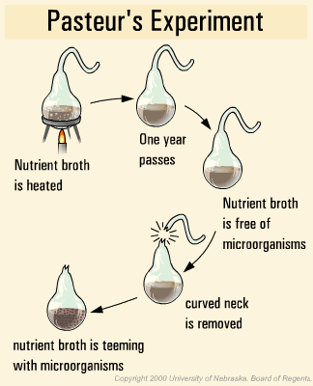

Following the discoveries of Redi and Pasteur, German scientist, Rudolf Virchow, and two other colleagues, formed a set of ____________________ called the
_________ ___________________.
- All living things are made of _______ or _______cells.
- Cells are the basic unit of _______________ and _____________ in all organisms.
- All cells come from previously existing ______________
____________are the individual, living units that make up all ___________________. The name cell comes from Robert Hooke(1635-1703) who coined the term cellulae when he observed tree bark under a microscope.
Some organisms are ___________________(2 or more cells) and others are ____________________(single cell). Most microscopic organisms are unicellular organisms.
Even though this organism is tiny it is still comprised of millions of _______________.
What Does Mycoplasma And a Blue Whale Have in Common?

Questions to Consider
- How might the cells of a multicellular blue whale be different from the cell of the unicellular mycoplasm?

- How might your cells be different from the cells of another animal or plant?
Structures in cells have specific ___________________, these structures are called _____________________.
Cells have:
  - a “_____________________” that directs all cell movement, growth, and other life functions
  - a “_____________________” to provide energy for carrying out those activities
  - a “______________________” that lets in needed material and lets out waste material.
______________________ – Often the most easily seen structure in a cell, it is often round and found near the middle of the cell. The nucleus is the control centre of the cell that directs all activities of the cell.
- The __________________ contains genetic (hereditary) information that is organized into threadlike structures called ____________________. Each chromosome contains different ________________.
- Genes are groups of genetic____________________ that determine the specific characteristics of an individual.
_____________________________ – a thin layer that surrounds the whole cell and protects the cell’s contents. The cell membrane is like the gatekeeper that controls the movement of materials in and out of the cell.
_____________________________– a jellylike liquid inside the cell where other cell parts float. Nutrients are absorbed, transported, and processed within the cytoplasm.
____________________________ – Balloon-like spaces within the cytoplasm that are the storage places for surplus food, and other substances that the cell cannot use right away.
____________________________– Sausage shaped energy producing organelles in the cell. Some cells have more mitochondria than others because they need more energy.(ex. Muscle cells)
____________________________ –Oval shaped structures in which the process of photosynthesis takes place. Only found in green plants and some unicellular organisms. Chlorophyll is found in the chloroplasts.
____________________________– occurs only in plants, fungi, and occasionally in some unicellular organisms. It is a rigid frame-like covering that surrounds the cell membrane and gives support and structure to the organism.
____________________________– This organelle is like a highway, where materials are transported through the cell or to the outside of the cell. The endoplasmic reticulum is a folded membrane.
Outside the cell membrane, some cells have a _____________________ which is a whip-like tail that assists with _____________________.
Some cells have many hair-like structures called ________________ that help the cell move about its surroundings.

