Science 10 Name: ______________Date: _____
Exploring the Universe.
Explaining the Universe.
- __________________________________________ discovered that all galaxies are ___________________________ from each other
- According to the ______________________________, the universe is believed to have begun during an unimaginably rapid expansion of a tiny volume of space, about _____________________________________________________. All the matter in the universe is thought to have been created at that moment.
- Early _____________ were able to observe outer space by using the best instruments of the time, early____________.
- With the development of more powerful telescopes in the 1920’s, suddenly more _________________________ were discovered.
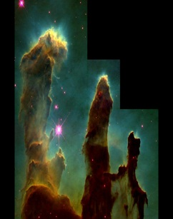
- Celestial bodies is a general term for all the objects in the sky, including the ________, _____________, __________, and ____________.
- ________________________ an American astronomer was the first one to identify __________________ besides the Milky Way. He estimated the distance from earth to ___ different galaxies.
Hubble's Proposal
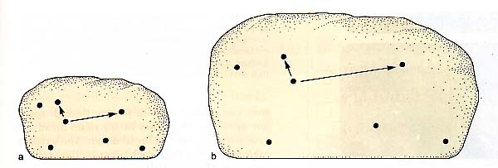
- Hubble proposed that the universe _______________. The galaxies which are further away from Earth are moving apart ______________ than those closer to Earth. He used the analogy comparing an uncooked loaf of raisin bread to one that is put into the oven. As the dough rises the raisins (galaxies) are moving further away from each other.

Red Shift Analysis
- Edwin Hubble figured out that _________________ were moving away from the earth at a certain speed, which was proportional to the distance from earth. He did this based on his understanding of the ___________________________________________.
Electromagnetic Waves
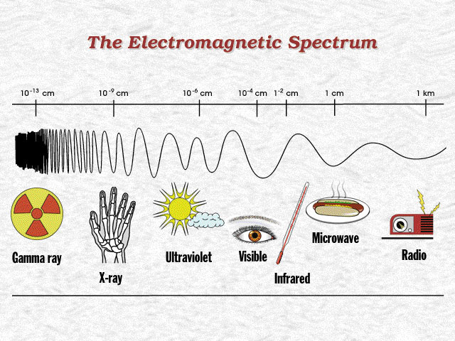
- ___________________ is only one form of energy that reaches the earth from distant stars (sun). Many other forms of energy with various wavelengths can be measured. These range from _________________________ to the __________________ which are ________________________.

Special Patterns
- ________________ splits into the different lengths of colour when passed through a ____________. This is called the_______________________. Light from distant stars can be collected and divided into individual spectral patterns. A __________________ will show the spectral pattern in a __________ in a certain _______________.
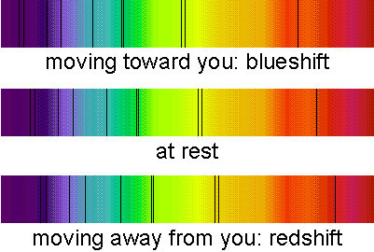

Cosmological Red Shift
- Edwin Hubble noticed that the light of the galaxies he was studying showed spectral lines that were shifted toward the __________________.
- This ________________ occurs because of the light’s wavelengths becoming ____________.
- This is an indication the galaxies are ______________________ from us.
- ____________________ call this the ____________________________________, which is evidence for the theory explaining the early universe.
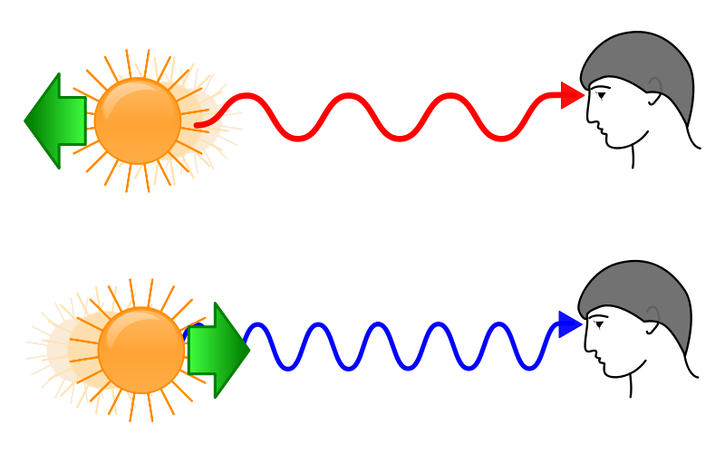
- A red shift means the wave length is getting longer, and the start is moving away from us.

- Blue shift is the opposite; the star is getting closer

Big Bang Theory
- Today the most widely supported theory is that approximately _____________________ years ago an unimaginably tiny volume of space suddenly and rapidly expanded to immense size.
- In that time all the matter and energy in the universe was formed. This is known as the ______________________________.

Cosmic Background Radiation
- In 1963 two astronomers ___________ and _______________were monitoring microwave radiation in space. To their surprise they kept receiving background “______” or signal interference. Their conclusion was they were actually detecting ___________
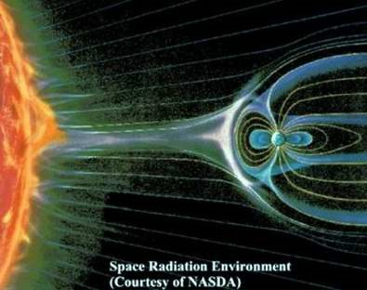
_______________. They believe this was radiation ________________ from the Big Bang expansion.

Additional Supporting Evidence
- Strongest evidence to date comes from the ___________________________________. The left over radiation from the earth’s expansion due to the Big Bang forms ______ and ________ indicating the age since the expansion took place. The reds indicate hotter temperatures and the blues represent cooler temperatures which indicates the _______ since expansion.
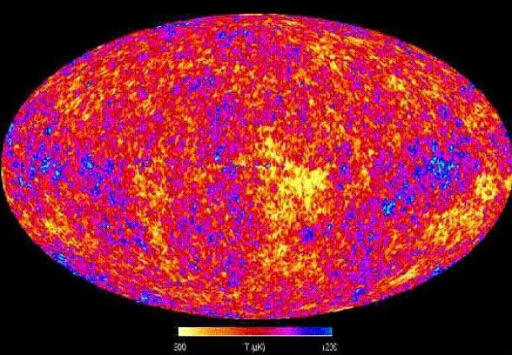

Trying to Simulate THE BIG BANG THEORY
- What is a "_________"?
- Quarks are thought to be smaller ____________________ that make up ___________ and ___________________.
- Scientists are trying to learn more about these sub atomic particles by attempting to smash them in a sophisticated ________________________.
- By firing protons at each other they are attempting to smash apart these particles.
- Scientists believe that studying these particles will help them understand how protons and neutrons were ___________________________.

Galaxies
- Galaxies are collections ___________, ____________ and ___________ held together by ______________.
- Scientists believe there are about ________________ of these structures in our universe.
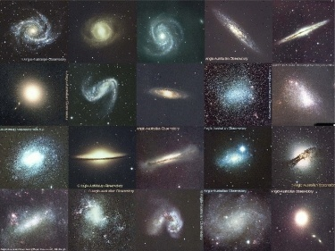

- There are ____________________ or galaxies: a) _____________________, b)______________________, c)__________________________.
- The ____________________________ where our sun is located is a spiral galaxy.
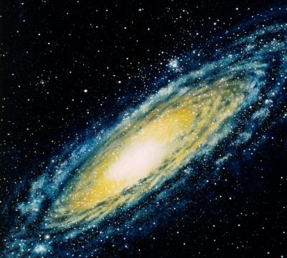

Galaxy Shapes
- Spiral
- These appear like ______________________ with many long arms spiralling out from the center.
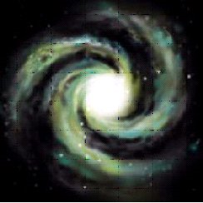
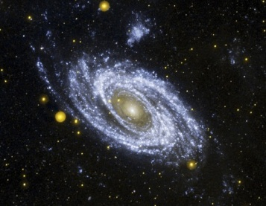
- The center bulge is made up of __________________ formed long ago, while the circling disc is made up of ________________________. This area is called the ________.

- Elliptical
- These galaxies contain some of the ____________________ in the universe. They range in shape from football field to a cigar.
- Over ________ of the galaxies are elliptical and many are also the ______________.
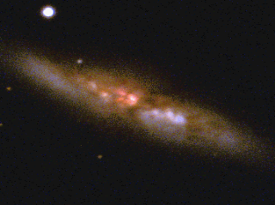

- Irregular
- These are made up of a micture of __________ and ___________________. They _______________ have distinguishing shapes like the elliptical or spiral galaxies.
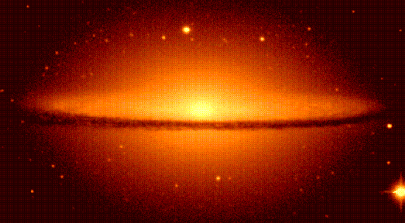

Other Differences Between Galaxies
- Galaxies can also ________ in __________, _____________, __________, _______________________ and ___________ they spin.
- These differences are determines by;
- _______________________________
- ______________________________
- _____________________________
Some galaxies grow into ________________ while others remain ________________.
Star Clusters
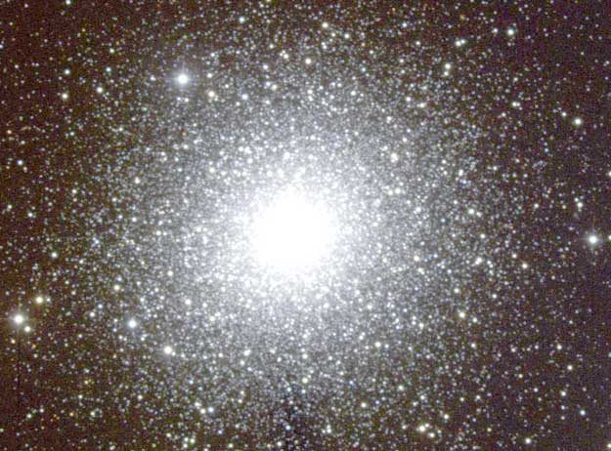
- One type is called a "____________________". These are composed of as many as ____________________________ held together by their mutual gravity in a ___________________________.

- The other type is called an “______________________.” These only contain between a _____________________ and ______________________________ of stars.

