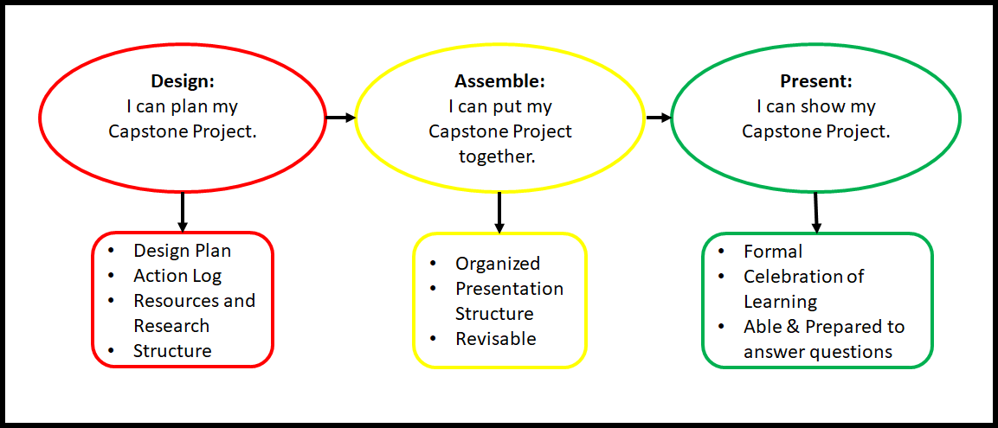

Design:
- Plan: Your accepted Capstone Proposal (from CLC 12A), including the planning structure you choose (model/template, MyBlueprint portfolio, notes, video, etc.).
  - What is your focus? What is your purpose?
  - Create an essential question. (eg. How can I use my experiences playing basketball as a starting point for a successful career?)
- Action Log: Your action log shows the different activities you completed to work towards your capstone, as well as the time you spent completing each activity. Document the time you spent learning about your essential question.
  - Timeline: Your proposed timeline for your project (PRIOR to beginning your project) as well as the record of your completed timeline (and how it differs from your proposed), the record of mentor meetings and your presentation dates.
  - Progress Journals: Working in conjunction with your action log, what represents your progress journals is dependent on both your learning style and your project strand. This may include photographs, audio files, videos, progress pictures, journaling, charts – anything that has contributed to your accumulated learning.
- Resources and Research: Explore, investigate and gather information. You may choose to interview mentors or local experts, use relevant information from MyBlueprint, blogs, WorkBC, First Nations Career Role Model Program, etc.
- Structure: Decide on a structure for your project. Think about how you will present your work to an audience.

Assemble:
- Organized
  - Use a thoughtful process
  - Make it interesting and compelling
- Presentation Structure
  - What form will your presentation take? (display, poster, PowerPoint, video, exit interview, vlog, blog, online/zoom, dance, essay, report, etc)
- Revisable
  - Make changes based on reflection

Present:
- Formal
  - Compelling, engaging, captivating, interesting
  - Final, presentation ready product
  - Showcase your learning to a person/people other than yourself
- Celebration
  - Celebrate my learning by sharing it with others.
- Able & prepared to answer questions

Self-assessment and Reflection:
- Self-assessment
- Rubric
  - Complete the checklist provided to you on the rubric.
  - Ensure that you have provided explanation for your areas of improvement as well as areas that you have excelled.

Timeline
Your timeline is the process from design to the presentation. An action log is provided for you to fill in as you work through this project; this will help you to keep track of how much time you are putting into the final product. It should include your approved proposal, your mentorship agreement, mentor meetings, progress journals, deadlines for research completed, and your finalized project and presentation.
Action Logs and/or Progress Journals
Remember when you completed your Capstone proposal? It’s time to put your proposal in action! From keeping track of your capstone progress, you will demonstrate your effort and ensure that you are providing evidence of the activities you are working on to complete your capstone project! By documenting your learning, you are showing that your capstone project is not just about product, but the process you used to get there!

All of the work that you do towards your Capstone Project should be done with the objective of working on your goal(s), your essential question and/or your presentation. Please ensure that your time is spent equally between all your objectives!

Some guidelines for your action log and/or progress journal:

You have spent time discussing and thinking about your future throughout Career Life Education and Career Life Connections classes.

Your action logs and/or progress journal should include time researching your topic (Career Inquiry, Learning Journey, or Personal & Meaningful Investigation).

Ensure that you include the time spent with your mentor or accessing first-hand information from interview(s).

Include your ‘action’ components in your action log and/or progress journal to show that you are putting your research to use, creating or testing it out.

Need inspiration for formatting an action log or progress journal? Look to these examples for help…

Action Log – consider using different action logs depending on what type of activity you are accomplishing!
Date | Time Spent | Description of activity | Work Accomplished | Resources Used or Contacts Consulted
Sept 29, 2020 | 45 minutes | Reading blogs online, WorkBC site, taking notes in my progress journal. | Researching jobs/careers with physical fitness | https://www.workbc.ca/Jobs-Careers/Explore-Careers.aspx

Progress Journals – consider using different progress journal templates depending on what type of activity you are accomplishing! Below is an exemplar you may choose to follow, and blank copies have been added to the following page.

Date: Sept. 29, 2020

Time Spent: | Resources Used:  (i.e.: time, space, materials, contacts) | Work Accomplished:
45 minutes | Meeting with mentor | Looking into career opportunities.
Successes / New Learning: Options for school to become a personal trainer are - kinesiology degree at the university, community programs from different gyms, apprenticeship hours with a licensed trainer, some different certifications available through the National Academy of Sports Medicine in CPT.

Challenges: There would be challenges in going to university to do kinesiology, as it is 4 years, and you need a lot more money to do a degree than a certification. However, while going to the university you do have access to the Northern Sports Centre, and I could maybe even get a job there. I would be difficult to make enough wage to go to school and live, so I may need to take out a loan. I would be able to do a lot of work online which has its own challenges, as I would have to be very careful to carve out time to do it, but it is only a one-year program online or 10 weeks with an instructor.

Next Steps: Make some decisions! I need to find out about funding and money, if I can work toward my personal training certificate while in university and working at the gym. I will need to do some research into the programs and career opportunities within this field. Maybe I want to work towards physiotherapy. Do I need another degree first? Where would I work?

Action Log - Capstone Project
Date | Time Spent | Description of activity | Work Accomplished | Resources Used or Contacts Consulted
Sept. 29, 2020 | 45 minutes | Reading blogs online, WorkBC site, taking notes | Researching jobs/careers with physical fitness | https://www.workbc.ca/Jobs-Careers/Explore-Careers.aspx

Progress Journal- Capstone Project
Date: | Time Spent:
Resources Used:  (i.e.: time, space, materials, contacts) | Work Accomplished:
Successes / New Learning:

Challenges:

Next Steps:

Date: | Time Spent:
Resources Used:  (i.e.: time, space, materials, contacts) | Work Accomplished:
Successes / New Learning:

Challenges:

Next Steps:

Mentor
As part of your capstone project, you can connect with a mentor who will provide guidance throughout your capstone project, giving you feedback and making suggestions. Remember some of those contacts you found in the Networking section from CLC12A? If you do not have a contact as a mentor, your obvious choice would be your Career Life Connections teacher. The time you spend with your mentor can be:
- Face to face
- By telephone
- By video conference
- Through email

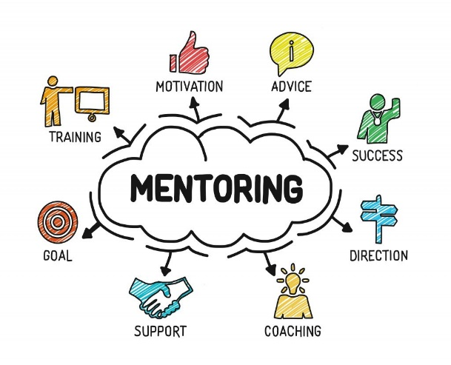
You must connect with your mentor throughout the project and track the time you have spent together. You should be meeting once per month with your mentor/Career Life Connections teacher.
What is a mentor?
A mentor is an experienced person in a field who provides knowledge and guidance to a student. Mentors offer experience, wisdom, guidance, encouragement, leadership, and a supportive relationship.
Who can be your mentor?
A mentor is usually an expert in the field you are interested in. Ideally, your mentor will not be a family member, however, please talk with your Career Life Connections teacher, if there are special circumstances. Think about people you know with knowledge in your interest area such as family friends, neighbours, colleagues, coaches, teachers or professionals in your community. You may need to reach out and do some networking in your community to find the perfect mentor for you! Refer to your Networking section from CLC 12A.
Although you will benefit the most from your mentoring relationship with face to face meetings, it is also acceptable to connect with your mentor through online communication. As you decide on a mentor, remember that the most important thing about a mentor is the relationship. Make sure you choose someone you are comfortable with and connect with. If you are having a challenge finding a mentor in your interest area, connect with your Career Education teacher TODAY for help!
Once you have connected with someone who has agreed to act as your mentor throughout your capstone progress, complete the information for your mentor below, as well as the capstone project mentor agreement form, provided on the next page.

What is your mentor’s name? | What is your mentor’s occupation and  their relationship to you?
Describe why you feel that your mentor will be a good support for you. What are the ways they can help?

Identify Secondary Supporters:
Secondary supporters are important too! Other than your mentor, who will support you in this process? Keep you on track? Remind you to work on your Capstone? Encourage your maximum effort? These people do not have to have knowledge of your specific topic area, but it helps!
Secondary Supporter: | Secondary Supporter:
How will they support you?

SCHOOL DISTRICT NO. 57: CAPSTONE MENTOR AGREEMENT FORM
Student Name: ______________________
Date: ________________________

Dear Career Education Teacher:

__________________________________________________ has requested that I serve as a mentor for their Capstone Project. I have expertise in the area of _____________________________________________________
_____________________________________________________________________________________________
and I agree to provide guidance in this field in order to support this student throughout the duration of their project. I understand that the student is required to initiate and organize regular meetings with me to keep me informed about their Capstone progress, in order to provide advice and feedback. Meetings can be completed face to face, by telephone, by video conference or through email, and should be at least once per month.
As a mentor, I will collaborate in several ways with this student, including but not limited to instruction in my field of expertise, offering direction or support for the student’s goals, professional guidance, feedback and encouragement.
I understand that all consequences of the project choice, production, or experience, unless otherwise stated, rest solely with the student and their parent or guardian. I have reviewed this Capstone Mentor Agreement and understand my expectations as a mentor. I will fill in the attached form: 2 starts and a wish.
I will contact the student’s Career Education teacher if I have any concerns about the student’s commitment or progress. I also understand that I will be invited to this student’s Capstone Presentation at the end of the school year, but I am under no obligation to attend.
Mentor’s Name:
Title / Position:
Mentor’s Signature: __________________________________________
Name and Address of Organization: _____________________________________________________________
Email Address: ________________________________________________________________________________
Telephone number:
The best time(s) to contact me are: _____________________________________________________________

This student’s Career Life Connections teacher is: ____________________________________________________
Their contact information is: _____________________________________________________________________

Mentor- Feedback Form Student Name: __________________________

What are two things your Mentee did well?
    - ____________________________________________________________________________________________________________________________________________________
    - ____________________________________________________________________________________________________________________________________________________

What is one area your Mentee can work on?
    - ____________________________________________________________________________________________________________________________________________________

Additional Comments: ________________________________________________________________________________________________________________________________________________________________________________________________________________________________________________________________________________________________________________________________________________________________________________________

If you have recommendations of other businesses, organizations or mentors who may be willing to accept a Work Experience or Mentorship student, please provide their contact information below. We will follow up with additional information.

Name / Organization: __________________________________________________________________________
____________________________________________________________________________________________

Email address: ________________________________________________________________________________

Telephone number: ____________________________________________________________________________

Thank you so much for mentoring students in the School District No. 57
to be better educated with their career-life decisions!

Your Capstone Presentation
Your final capstone project will consist of a presentation of your learning. Don’t worry – it’s not as onerous as it sounds, and you will have help and support along the way! This information will help you organize your research into a final capstone, which you will be proud to present.
Planning for your Capstone Presentation:
Your final presentation will be a showcase of your learning to show what you now understand about your topic.
Your capstone presentation might include any of the following:
- Career Options - investigation of a specific career or specific aspect of a career.
- Learning Journey- investigate how past, present, and future experiences are shaping your career life choices.
- Personal Interest - demonstrate a new skill or showcases something you have created (a passion project!).

Your Capstone can take many forms, such as a film or video, a document, a performance, or something you have created. Think about your essential question – what is the best way to represent your answer?
Examples: a robot you built, a game you coded, a live demonstration, a work ready application portfolio, a compilation of audio recordings, a final art piece / animation / fashion piece / cookbook, slide show, TEDTalk like speech, spoken word poem, a compilation of vlogs filmed along the way, a booklet of your learning evidence and journal, a short story about your journey, an essay…
This list is in no way exhaustive! Google “Ways to Demonstrate Learning” or “Ways to Present What You Know” to be inspired by different ideas. Think of how you learn best, how you could best present your topic and essential question (and answers!) and what representation style most inspires you!
Planning for your Capstone Presentation:
Your Capstone project includes a presentation – this is what you’ve worked so hard for! During your presentation, you will present your chosen capstone project. Your presentation, supported by evidence, will explain your interests, essential question, research, career explorations, and the link between them.
You are welcome to invite others to share in your capstone presentation, such as your mentor, your parents, friends, colleagues, family members or others that provide support in your life. You are likely nervous about speaking in front of an audience, but remember that you are the expert, and you have invested a significant amount of time and energy into this project! This is a huge accomplishment, and you should be proud of yourself!
Here are some hints and ideas to help with your presentation outline. Remember your goal is to provide the audience with a clear and concrete evidence of your capstone journey, and what you gained from the experience.
- Start by introducing yourself – how did you come to decide your capstone journey?
- What are your post-graduation plans and options? What options are you considering at this point? Why?
- How have you demonstrated and showed growth in the Core Competencies?
  - Career-life development includes ongoing cycles of exploring, planning, reflecting, adapting, and deciding.
  - Career-life decisions influence and are influenced by internal and external factors, including local and global trends.
  - Engaging in networks and reciprocal relationships can guide and broaden career-life awareness and options.
  - A sense of purpose and career-life balance support well-being.
  - Lifelong learning and active citizenship foster career-life opportunities for people and communities.
- Explain your capstone goal(s) and essential question through showcasing your final product. Discuss the journey you have experienced, your learning and your growth. Describe the contents of your project.
- How was this project a challenge for you? How did it stretch your skills, knowledge, and comfort zone?
- Where are you now on this journey? Have any new goals or questions come about through completing this project?
- What did this process teach you about pursuing your goals and lifelong learning?
Make sure you look at the rubric which will be used for assessment and feedback of your presentation before your presentation date!

The Nuts and Bolts of the Presentation:
Time

This will be determined by your school and your Career Education teacher. The presentation could take the form of a panel presentation, one on one presentation, or a gallery walk.

Professionalism

Appearance: you need to be dressed appropriately for your presentation, ideally in business casual. Your dress and personal appearance is an important part of the presentation, as it will show readiness for tackling your career-life goals.

Attendance: you are required to arrive at least 15 minutes prior to your presentation time. Prior to your presentation, please ensure that you send an electronic copy of your presentation to your Career Life Connections teacher (when possible). You must make sure that all equipment needed for your presentation is set and working before your presentation starts.

Presentation

- Make use of visual aids in your presentation, such as a PowerPoint, Prezi, video, audio, musical performance, demonstration or poster. Not only will that help with your nerves, but it will help your audience better understand what you have learned from your project.
- If your project resulted in an actual product, the product or photos need to be part of your presentation.
- If you are choosing to show a video as part of your presentation, please keep the video time to less than half of your presentation
- Ensure that you have practiced your presentation beforehand – it will show! As well, be confident, stand straight, speak to your audience at a reasonable pace and use eye contact.

Throughout your Capstone presentation, continually show evidence of your Core Competencies through the depth of your learning, the knowledge and skills that you developed and the way your project assisted your career-life decisions.

When presenting your Capstone, remember that it is not about whether you fully accomplished your goal. This process can be messy, and you may have pivoted your plan along the way.

Present your journey and your learning, along with your end product.

Capstone Project Self-Assessment Student Name: _____________________________
Dear Student:
Please take a minute to respond to the following questions. Your input is valuable in providing a basis for feedback for your Capstone.

- How much time, or how many hours would you estimate you spent working on your Capstone Project? How was this time generally divided between grades 11 and 12? (Use your action log/progress journal!)

- How would you describe your communication skills with your mentor in terms of communicating consistently, taking initiative in setting up meetings, and following through?

- How did you feel when given feedback on your project? Were you open to the ideas of others, and did you adjust your capstone accordingly?

- What, if any, changes in skills or attitudes have you developed throughout your time completing this project?

- What problems or challenges did you encounter with your project, and what problem-solving strategies did you use to conquer them?

- What was the greatest successes or the “best moment” that you achieved through completing your capstone project? What will you take away from it?

- Now that your presentation is complete, what are your future goals?

CLC12B – Capstone Rubric
What is a Capstone project?
- Structured from Career Options, Learning Journey, or Personal Interest
- Supported by audio and/or visual aids
- Explains your interests and your essential question
- Includes research and career explorations
- Produces a final product
- Makes connections based on all the information you collect on your journey

Curricular Competency:
- Design, assemble, and present a capstone project.
Emerging/Developing:  Areas that need improvement | Proficient: | Extending:  Evidence of going beyond the target
What is the design of my Capstone Project?

I can plan a Capstone Project.

Expectations:
- Inquiry – You have chosen your type of capstone, found a focus and purpose.
  - Career
  - Learning journey
  - Personal & meaningful investigation
- Research – Explore
- Resources – Gather information. I.e. Mentors, local people, relevant information, MyBlueprint, blogs, WorkBC, First Nations Career Role Model Program, etc.
- Investigate – Make your own connections based on the information found in your research and resources.
- Structure- You have decided upon a structure for your presentation.

How will I assemble my Capstone Project?

I can put together a Capstone Project.

Expectations:
- Thoughtful
- Organized
- Interesting
- Revisable
- Structured plan for learning journey
  - Model/Template
  - MyBlueprint portfolio
  - Notes (learning journal)
How will I present my Capstone Project?

I can present my Capstone Project to an audience.

Expectations:
- I showcase my Capstone Project in a formal manner
  - Engaging (Captivate your audience)
  - Interesting
- I am celebrating my learning by sharing it with others.
- I am able & prepared to answer questions about my Capstone Project

Final Capstone Project must include:
- Action Logs/ Progress journals
- Letter and Feedback Form from Mentor (if using someone other than your Careers Life Connections Teacher)
- Structured plans
- Final product
- Presentation
- Rubric with a completed reflection and self-assessment.

