Wellness is an active process of becoming aware of and making choices toward a healthy and fulfilling life. Wellness is more than being free from illness, it is a dynamic process of change and growth.

"...a state of complete physical, mental, and social well-being, and not merely the absence of disease or infirmity."
- The World Health Organization

"a conscious, self-directed and evolving process of achieving full potential."
- The National Wellness Institute

Maintaining an optimal level of wellness is absolutely crucial to live a higher quality life. Wellness matters. Wellness matters because everything we do and every emotion we feel relates to our well-being. In turn, our well-being directly affects our actions and emotions. It’s an ongoing circle. Therefore, it is important for everyone to achieve optimal wellness in order to subdue stress, reduce the risk of illness and ensure positive interactions.

What are 3 things you currently do in order to maintain your own personal wellness?
-

-

-

What are 2 things that might sabotage your personal wellness?
-

-

Personal well-being can be thought of as a balance of four main categories: Emotional, Mental, Physical and Spiritual. While we often find ourselves prioritizing individual categories at some cost to others, maintaining personal well-being is all about finding ways to balance these areas.

Please look at the following graphic from the First Nations Health Authority (www.fnha.ca). It shows a holistic view of health and wellness. In the Center Circle, you can see that wellness should start with the individual taking responsibility for their own health and wellness. The Second Circle shows the importance of Mental, Emotional, Spiritual and Physical aspects of a healthy and well-balanced life. The Third Circle shows the overarching values of Respect, Wisdom, Responsibility, and Relationships. The Fourth Circle shows the people around us and the places from which we come. The Fifth Circle shows the Social, Cultural, Economic and Environmental factors in our health and well-being. The Outer Circle represents the children, families, elders and people in communities, Togetherness, respect and relationships play significant roles in personal health and well-being.
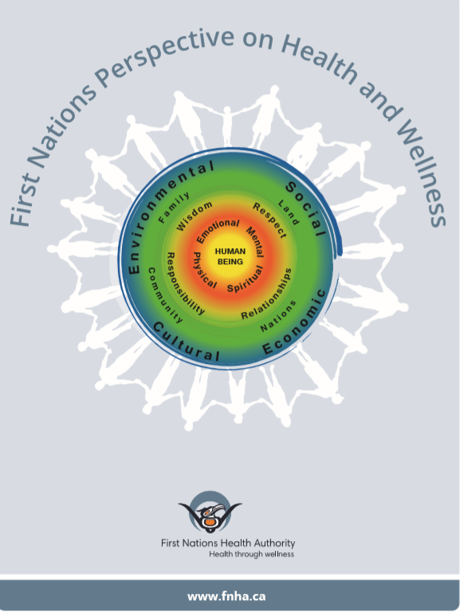
Reflect: Do you find that you currently prioritize one of these aspects more than others?

Identify 3 steps that you can take to achieve and maintain balance in your well-being. Think about how you can change or affect different internal and external factors. Consider what is in your control and what is out of your control.

-

-

-

What challenges and/or opportunities might you face as part of your plan?
-

-

