How do you present yourself to the world? Is your personal profile different from your professional profile? How do you represent yourself on social media? Are you digitally literate? All of these questions, and more, are things you need to consider as you transition into the next stage in your life and into the world of work.

Skills:
Digital Literacy includes online safety skills, functional skills, critical thinking and evaluation skills, cultural and social understanding, collaboration and creativity, effective communication and netiquette, and information finding skills.
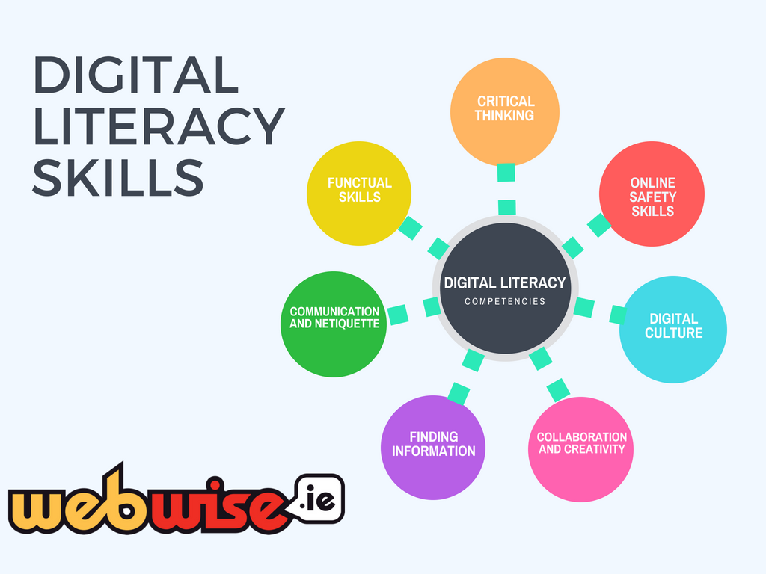
(https://www.webwise.ie/teachers/digital_literacy/)

Reflect: Rate your competencies in the various skills involved in digital literacy?

What is one digital literacy skill that you could improve upon? How?
________________________________________________

-

Your Impact:
You can think of your impact and presence within the world as your footprints. The metaphorical pathways that you take through the course of your life’s actions contribute to your public persona. It is important to reflect on our footprints, as well as to cultivate them so as to ensure that we present ourselves in a positive manner in public.

Your digital footprint is anything that is about you or put out by you online. That includes social media, your own website, articles about you or written by you. It spans all time and doesn’t just include what’s found at the top of the page—it can be information that is both easy and hard to find. Actively maintaining your digital footprint can have positive benefits on your employment experiences.

Your online presence is not the only aspect of your public persona that you have control over. A carbon footprint is the total amount of greenhouse gas emissions that come from the production, use and end-of-life of a product or service. It includes carbon dioxide — the gas most commonly emitted by humans — and others, including methane, nitrous oxide, and fluorinated gases, which trap heat in the atmosphere, causing global warming. Usually, the bulk of an individual’s carbon footprint will come from transportation, housing and food.

You also have impact on the lives of those around you through relationships, behaviors and communication choices. Relationships can include how you work with your colleagues, how you treat other people in public and in private and how you relate to those around you. Your behaviors and body language often talk for you before you even start to speak. This can be online and in person. Your communication choices also reflect yourself and have an impact on other people. Micro-aggressions are words, statements, actions, gestures, behaviors or other incidents of discrimination, against members of a marginalized group. They can be both indirect and direct, subtle or overt, unintentional or intentional. What you say or how you say it, how you behave or act, impacts those around, whether you realize it or not.

What are 3 ways you can positively impact the world and those around you.
-

-

-

What challenges and/or opportunities might you face?
-

-

-

Personal Brand and Personal Marketing:

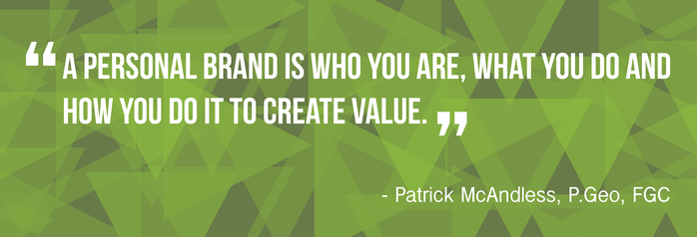
(https://geodudecorner.com/brand-statement/highschool/)

Knowing how to consistently, concisely and coherently describe yourself in a genuine manner is one of the toughest but necessary skills in the world of work. It helps you in job interviews. It helps you select best fit careers. It helps tell your story even when you are not in the room.
The following activity is based on activities and resources from the GeoDude Corner website (https://geodudecorner.com/brand-statement/highschool/)

The purpose of this activity is for you to assess who you are, how you want to represent yourself and your potential to make a difference and create value. You will take inventory of your personal skills, strengths, values, passions and goals. Then you will develop your personal brand statement.

Skills: What have you learned to do well? Choose your top 3.
-

-

-

Strengths & Aptitudes: What are you naturally good at? Choose your top 3.
-

-

-

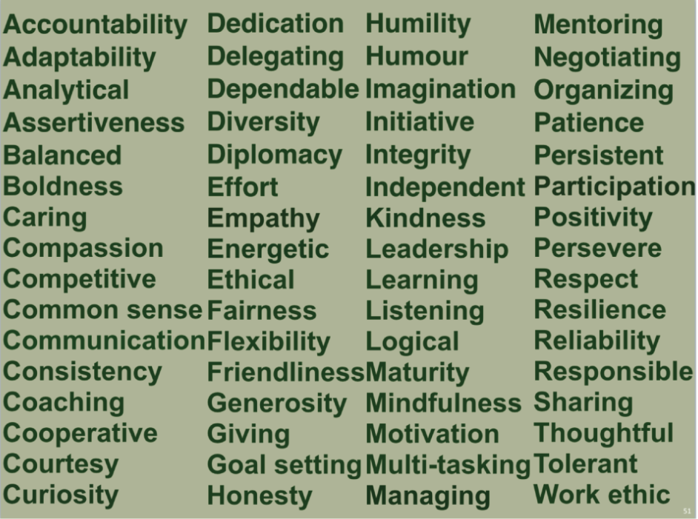
Values: What is something that is important to you?
Examples: | Your top 3 choices:
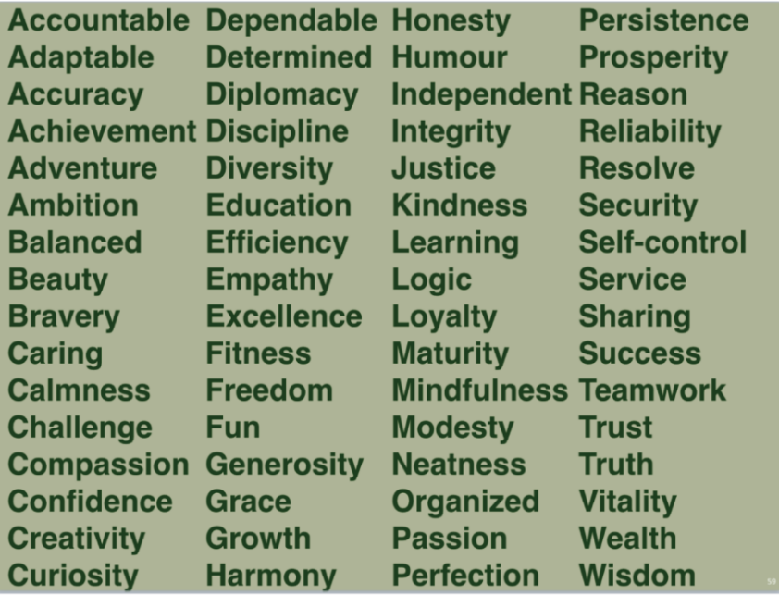 | -  -  -

Reflect: What are your passions or things that you love to do or that create a strong feeling of excitement)?

Goals: What is 1 thing you want to be doing in 5 years to create value?

Action Word: What word best describes how you will create value?
Example: | Your Choice:
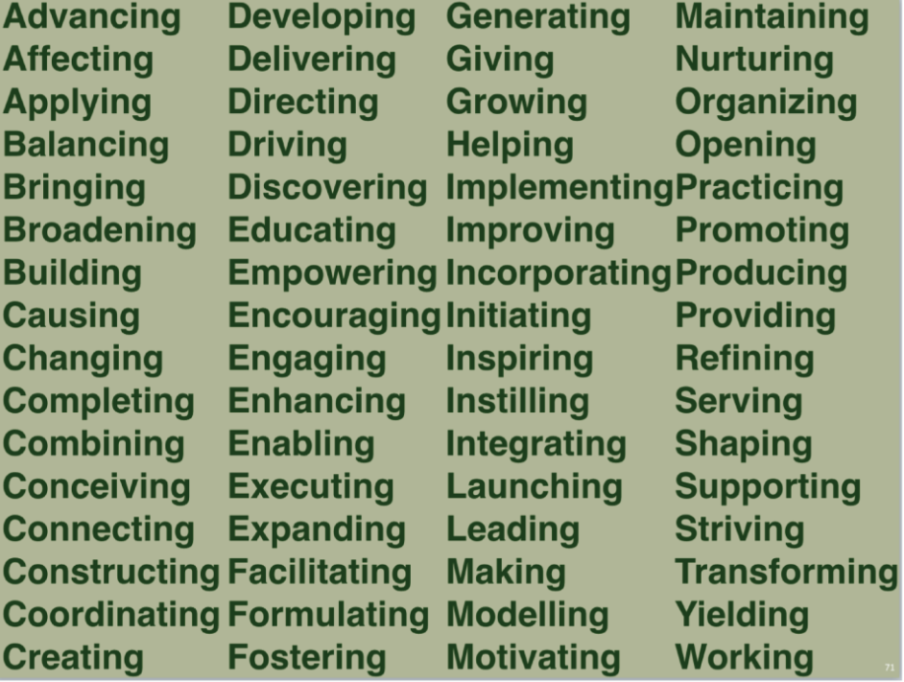
Brand Statement: What will you brand statement be? (10-15 words starting with an action word describing how you will create value)
For example:
“Helping my community with small actions that make big differences.”
“Shaping ideas into a reality to advance technology.”
“Constantly improving myself though innovation and dedication.”
“Working to improve lives through altruistic actions and leading by example.”
“Exploring my passions through persistence to create change in the world.”

You want to convey a consistent, personal brand statement/image in your professional and social networking, in job interviews, in your resume, and in your cover letter.

