Why do you need to register for the BC Student Transcripts Service?
To:
- View and order secondary school transcripts
- Send your student transcript to post-secondary institutions (colleges and universities)
- Order a graduation certificate (if graduated)
- View provincial exam or graduation assessment results
- View BC Scholarship awards received

What do you need to do?
To create your account with the BC Student Transcript Service:
- Google BC Student Transcripts Service (click on “Order a High School Transcript, and scroll down)
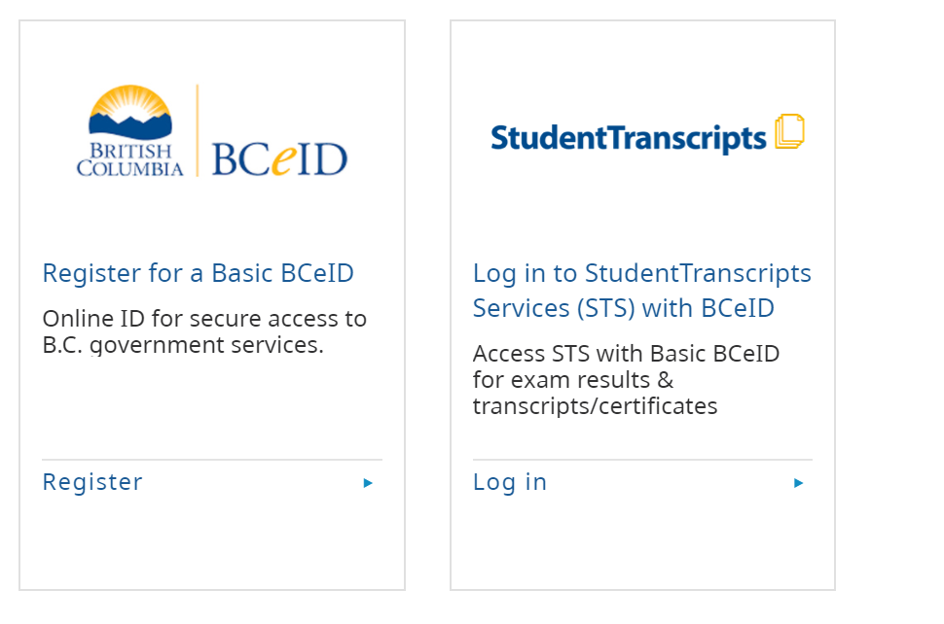

OR go to https://www2.gov.bc.ca and search Student Transcripts Service (click on the highlighted StudentTranscripts or Basic BCeID as needed)
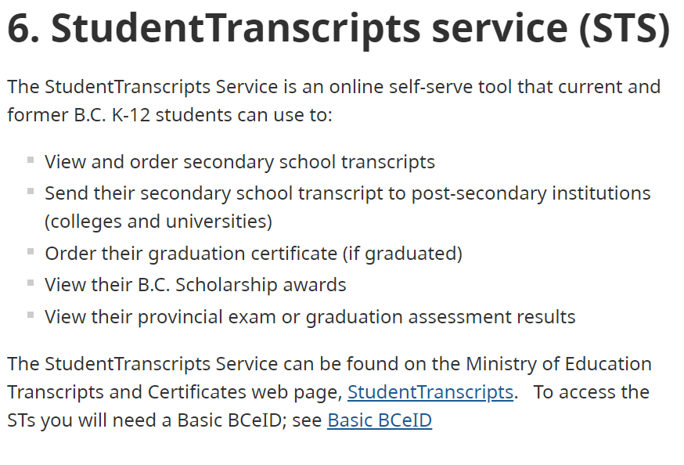

NOTE:
If you have not already created an account, you must first create a BCeID (follow the link).
- You need your Personal Education Number (PEN). Find this 9-digit number on the right hand corner of any report card or obtain it from your counsellor.
- Create a BCeID account. Then follow system prompts and register for the Student Transcript Service.

- . You may have to click on “Current Student” from the webpage you are on.
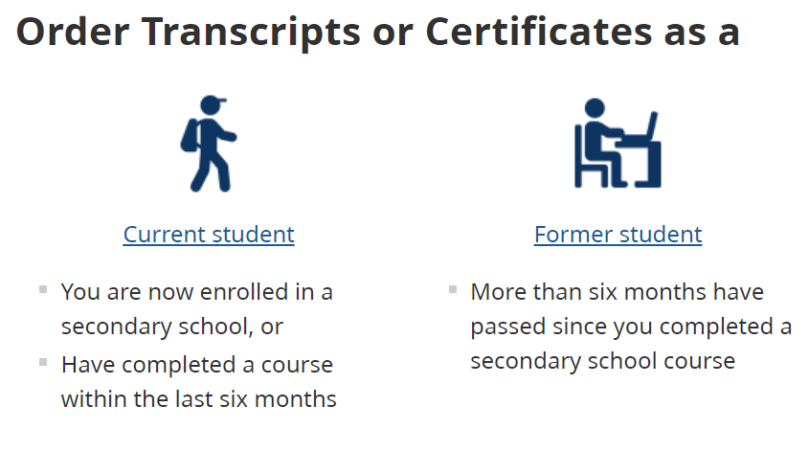

- Login to the Student Transcript Service using your BCeID

- Print off your Unofficial Transcript.

- Transcript printed and handed in to CLC 12B teacher

To send your transcript to a post-secondary institution:
The Post-Secondary Institution (PSI) Selection Form allows you to authorize the Ministry of Education to forward your INTERIM OR FINAL OFFICIAL TRANSCRIPT to post-secondary institutions of your choice. It is a good idea to send your transcript to any institution you think you might attend.

- On My Dashboard, click the “Send/Order Your Transcript” menu option
- Tick the “I consent” box
- Select “Send Transcript”
- Make selections.
- Go to Next Step
- Select “Send Interim and Final Mark when they become available.”
- Go to Next step.
- Tick “I have reviewed my order and course information.”
- Add Order to Cart
- Submit Order

- Transcript sent to at least 1 post-secondary institution.

**Students applying to post-secondary institutions must complete the PSI Selection Form process by May of your graduation year for Interim transcript data to be made available to the post-secondary institutions or June of your graduation year for final transcripts to be made available to all post-secondary institutions in late July**

See following YouTube links for additional support:

https://www.youtube.com/watch?v=xJCk3Uj3P0Q

https://www.youtube.com/watch?v=SSo_U7XmH8k

