DNA REVIEW
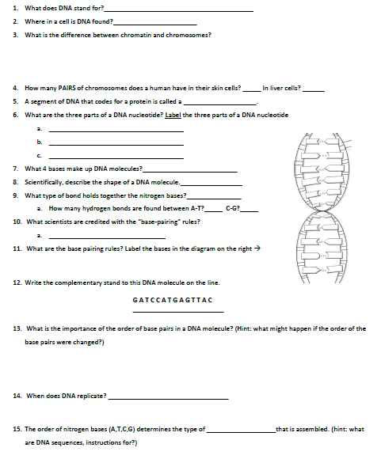
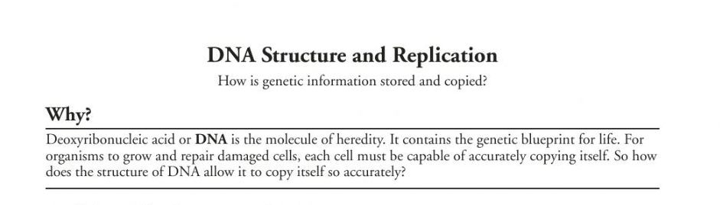
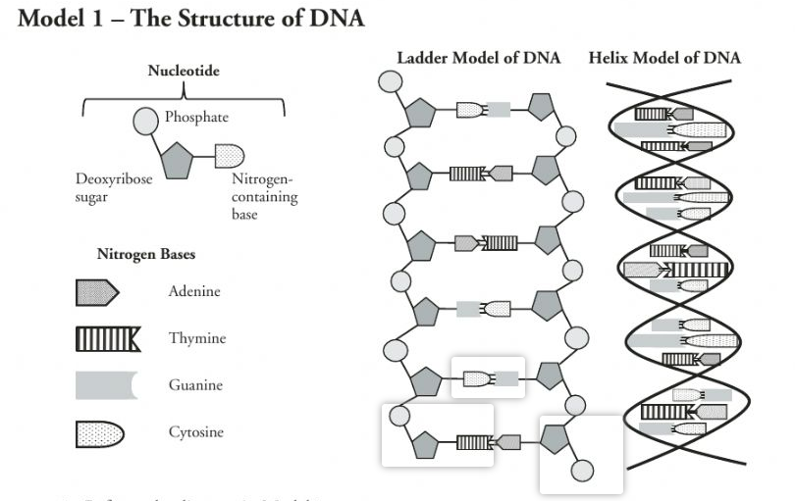
Use the model to answer the following:
- What are the three parts of a nucleotide?

- What kind of sugar is found in a nucleotide?

- Which nucleotide component contains nitrogen?

- Name the four nitrogen bases shown in the model above.

- DNA is often drawn in a twisted ladder model (Double Helix). Locate this drawing in the Model above.

  - Circle a single nucleotide on each side of the ladder of DNA.
  - What parts of the nucleotide make up the rungs of the “ladder”? _________________________
  - What parts of the nucleotide make up the backbone or sides of the “ladder”? _________________________

