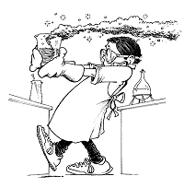
Topics:
- General Rules
- Clothing
- Accidents and injuries
- Handling Chemicals
- Handling Glassware
- Heating substances

Project: Lab Safety Brochure

- Create a brochure about lab safety. Fold a blank piece of computer paper into thirds to make your brochure paper. Your brochure will be a guide about five rules of lab safety. You must include detailed information about each rule and why it is important.
- You will be graded on neatness, the information that is included.
- You do need to color your brochure.

The following are some examples of safety procedures that could be included:
Eye, glass, heat, protective clothing, spill clean up, fire safety, chemical safety, eating and drinking, proper clothing, hair, shoes, horseplay etc.
Rubrics for Lab Safety Project
The following rubric was developed to guide you to the maximum scoring opportunity.
Safety Brochure Rubric
Category | 0 points | 5 points | 10 points
Safety Rule(s) | not stated | Partially stated | Completely stated
Explanation of Lab Rule(s) | None | Partially explained | Clearly explained
Color and neatness | No color and sloppy | Black & white plus sloppy | Colorful and neat
Appropriate sketches or pictures | < 2 | 3 - 4 | >5
Appropriate explanation of WHMIS and caution labels | None or minimal included, no or minimal explanation. | Some or most included, and explained satisfactorily. | Most or all include and explained very well.

