Periodic Table Alternate Lesson
- Periodic table questions from the essay we read.
- Go to this website: https://www.pbslearningmedia.org/asset/phy03_int_ptable/
  - Answer the mystery questions and discover information about the elements of the periodic table.
- .Now complete the following information from the periodic table into this scavenger hunt. The Periodic table can be found on the class website at the top righhand side. 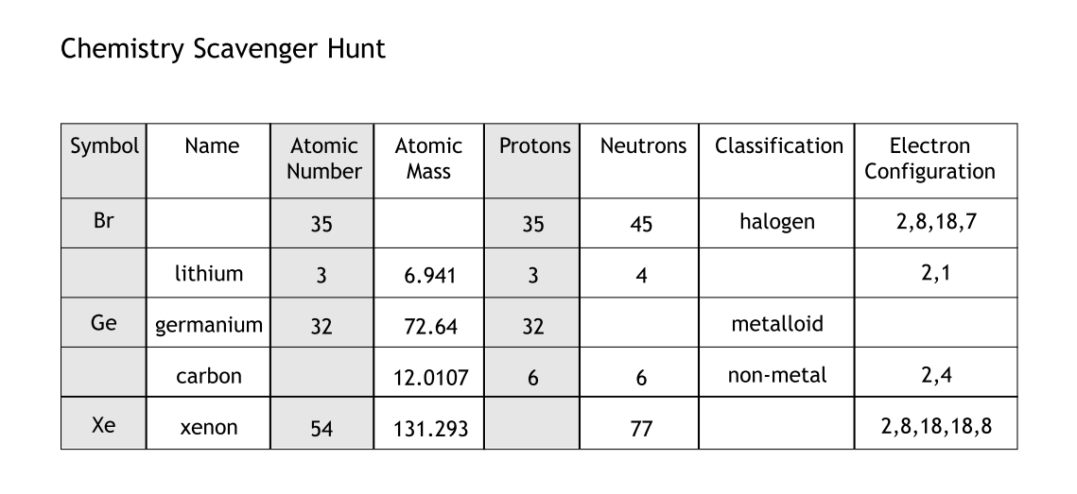
- Create some scavenger hunt questions of your own by adding to the chart above.
- Colour the large 11x17 periodic table following along with the slideshow. As you go through the slideshow be sure to watch the videos attached, and read through the information.
- Review Bohr Rutherford diagrams.

