Science 10 - Course outline
Mrs. House 2022
Contact information: dhouse@sd57.bc.ca or (250) 997-6510 ext. 199
Education is not the learning of facts, but the training of the mind to think.
~Albert Einstein
Course Overview:
Welcome to grade 10 Science! This year we will be studying four main topics.
Biology - DNA is the basis for the diversity of living things.
Chemistry - Energy change is required as atoms rearrange in chemical processes.
Environmental Science - Energy is conserved. Transformation affect living things & environment.
Space/Physics - The formation of the universe can be explained by the big bang theory.

Resources and Materials:
To help with consistency in communicating between parent, teacher and student I have chosen to create a website for our course this year. The website will share videos, links, materials, assignments, etc.

The website link is: http://sd57house.weebly.com/science-10.html

What students will need to bring with them to class each day:
- Mask(s)
- Binder preferably for science only, or organized well with dividers
  - Teacher generated notes, handouts, and course material
- Pencil and eraser
- Lined paper
- I will provide coloured pencils and markers when needed

Homework, Assignments, and Projects
Bell work: To begin class we will complete a review question designed to activate prior knowledge that will be useful in understanding new content. These questions are to be written down and answered in a duo-tang that I will provide for each student. These answers count toward class preparedness and participation. Many of these questions will be found on quizzes and tests. Essentially this becomes your ultimate study guide for the exam. If you are late to class you may miss the bell work for that day, do your best to be on time. **ALL quizzes, labs and work that has been marked should to go into your bellwork folder.**
Notes: Binders should be kept in chronological order. This means all new notes should go into the back of your binder. Notes should be neat and easy to read, with a title and a date. All notes and handouts should be in the appropriate section of your binder. If you are absent it is your responsibility to collect missed work from peers, or make arrangements with me prior to absence.
***Remember to check the “extra” bin for missed handouts, or print them from the course website.***

Tests/Quizzes, Projects and Labs: Science is largely experiential in nature and will require a good mix of written, vocal and hands on learning. All written work and rubrics are expected to be kept and organized accordingly within your science binder. ******Any student with an unexcused absence on the day of a quiz, project or lab will receive a mark of zero unless a note is provided from a parent/guardian, excusing the student from the missed class. Arrangements will be made for an alternate assignment.******

Homework: There will be no official homework done throughout this course. Through many readings and research, I believe that homework does not aid in a students’ ability to recall, retain, or gather information more effectively. Because science is very experiential in nature it is more effective to do work in class. HOWEVER any work that is not completed by the student within the given class time, becomes work that needs to be completed at home.
I.e. do your work in the allotted time, and never have homework.

All tests/quizzes, projects and labs will be evaluated in one category, class work. There will be a final for each unit either as a test or project, and a cumulative Exam.

Bellwork: 15%
Classwork: 60%
Unit Test/Project: 15%
Exam: 10%

Grading:
A Extending 86-100%
B Applying 73-85%
C+ Developing 67-72%
C Beginning 60-66%
C- Emerging 50-59%
I Incomplete/In Progress 0-49%

Classroom and Learning Expectations:
- Raise your hand if you would like to share within the class.
- You must have permission to leave the classroom.
- No eating in class, as there are chemicals used often.
- All liquids must be in a sealable/closable container.
- Your personal devices should not be seen unless they are being used appropriately and respectfully. Appropriately means used for classroom purposes (research, reading, viewing media purposefully, online dictionary, etc.) and respectfully means in a way that does not disrupt others’ learning. For example, the use of headphones is required when viewing media or listening to music. Inappropriate use will result in removal of device to be returned after class, repeat offenders will result in removal of phone only to be released to the student after school from the office. There will be contact home if cell phone use becomes an issue in class.
- If you are absent it is required that you catch up. It is your responsibility to contact peers or make arrangements to get notes or handouts.
- Follow lab procedures in order, with the knowledge of all safety precautions and guidelines.
- Be respectful of yourself.
- Be respectful of others.
- Be responsible for all of your actions and understand the consequences of your actions.

Three strike policy:
If a student chooses to ignore expectations:
- First Consequence: Verbal warning.
- Second Consequence: Second verbal warning and restorative justice
sheet to be filled out and signed by the teacher.
- Third Consequence: Contact home. Depending on severity of action
student may need to be removed from the class until action can be taken to set boundaries.

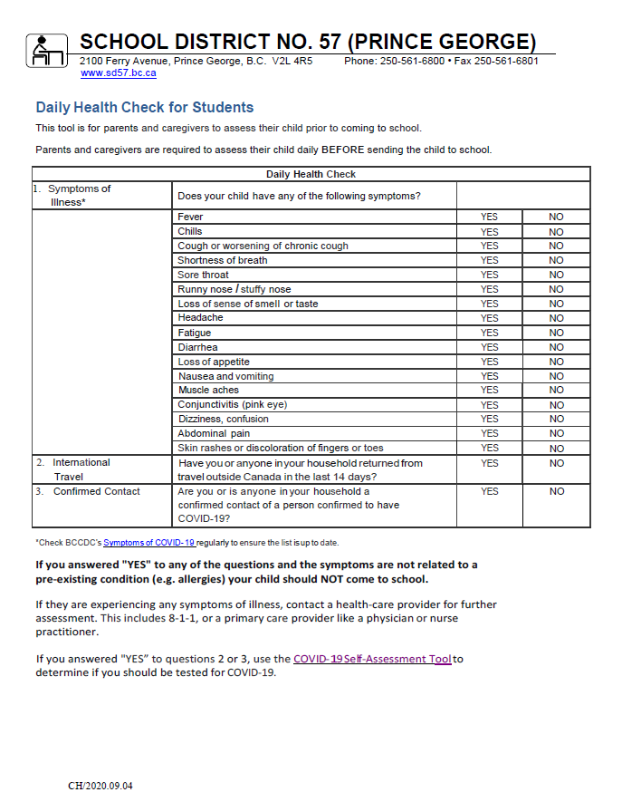

Please review this outline with your parents and return only this page to Mrs. House within the first week of school.

- I have read through the outline and acknowledge the expectations for this course.

Student Name: ________________________________________

Student Signature: _____________________________________

Parent name: _________________________________________

Parent e-mail(s):_________________________________

Parent signature: ______________________________________

Please do not hesitate to call or email me to set up a time to meet throughout the semester.

Thank you,

Danielle House

