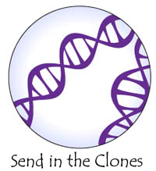
Send In the Clones
Would a clone of yourself actually be you? People might tell you that you have your mother's eyes or your father's smile, or that your sister looks just like you did at her age. Why is that? You know that you are different in some ways from everyone in your family, but the fact remains that children look like their parents, just like you look like yours.
Children look like their parents because they share _______________________________. The genetic material of a cell is called deoxyribonucleic acid, DNA for short. The genetic material of a cell acts as a blueprint for what we look like. Half of your DNA is from your mother and the other half is from your father. You have your mother's eyes because you have those genes, specific units of ______________, from her that control eye color and shape.
Those _____________ came to you when your mother's __________ fused with your father's _________________. Egg and sperm are specialized cells for ________________________. These cells are called ____________________. Gametes only contain _______________of the amount of DNA a cell must have to live. This is because they eventually come together and _________________their DNA. The process of egg and sperm joining is called ______________________________.
These cells only exist in special parts of the body used for _________________________. The rest of your body is made up of cells that have the entire DNA they must have to live. Those cells that are found outside the reproductive organs are called _________________ cells. This word is easy to remember if you know that soma means _______________ in another language.

Natural Clones
When an egg is ______________________ with a sperm and the DNA mixes, the cell starts _____________________________. Dividing cells is the way we grow from one cell to many _________________ cells, which is what you are right now. Sometimes, the dividing mass of cells ______________ (Spontaneously!) into two masses of cells. Both masses keep dividing. The cells all have the_____________________ DNA. The two eventually grow into two kids with the same DNA. They are then known as identical twins.
These kids have the exact __________________ DNA, which is exactly what a __________________ is. Yes, we already have human clones walking among us! Amazing right? Perhaps you know some identical twins? If you do, you might know that they might look the same, but they are very unique people in many ways. That is why a clone of you might not be you at all in the end. They might just be a separate, unique and beautiful person, like you, but different.

The Story of Dolly
Dolly is the name of a _________________ that has the honor of being the first mammal to be _________________ by a group of scientists in Scotland. Dolly was born July 5th, 1996 and she passed away in 2003. She lived for _________ and a __________years, as a normal, active ewe. She was not that normal though, she was a clone after all.
There are several breeds of sheep in the world. The sheep we focus on here are easy to remember though. One breed of sheep is the Scottish Blackface and the other is a Finn Dorset. What is easy about those names is that the Blackface actually has a black face. The Finn Dorset is all white. You know that the _________________ _________________ in our cells determines how we look on the outside. The black face of the Blackface sheep is determined by its ____________________ material, which means you can check to see who has that genetic material by just looking at their face! Very easy!

How Dolly Was Made
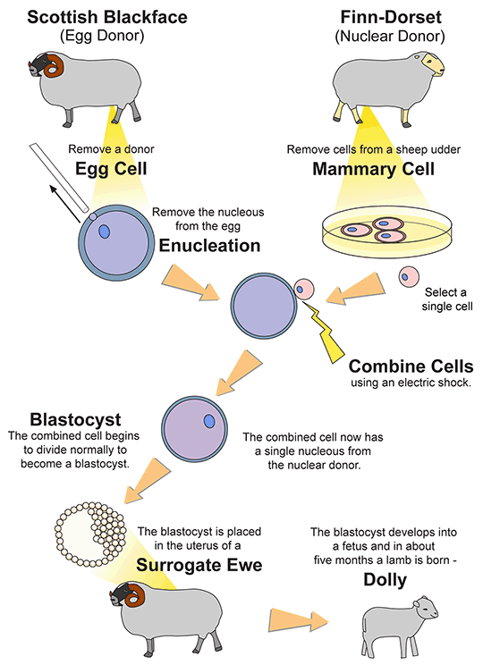
In Dolly's case, the ____________________of an egg from a black faced sheep was __________________________. The nucleus from a white faced sheep was_____________________________ into that egg. Now, they had just ________________ cell with the nucleus of a white faced sheep, but the rest of the cell containing items from a black faced sheep. That cell was placed into the black faced sheep who's egg it started out as. The cell eventually grew up and made Dolly. When Dolly was born, her face was white!
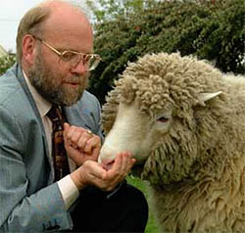
Black faced sheep never have white faced sheep. Dolly's face being white was good ________________________ that the experiment was successful, but scientists double checked Dolly's genetic material. They found that Dolly _____________ have the exact same genetic material as the white faced sheep that _______________________ the _______________________. Dolly did not have any genetic material from the black faced sheep who was her ________________________.

Scottish embryologist, Iam Wilmut, feeding his cloned sheep Dolly. The first mammal to be cloned.
The story was first published as a short report in a scientific journal called Nature, Volume 385, 1997, pages 810-812. Since that time, attempts at cloning at least _________________ species of mammals have been made. Only _________________attempts have been successful; cows, sheep, goats, mice, pigs, cats, and rabbits. The rate of success is very _________________.
Several questions are brought up by Dolly's life and death. Scientists were interested to see if she _____________faster because the genetic material was ______________ than that from a fertilized egg. It was thought that she was aging faster, but no one could be sure. Dolly's cells looked a little older in a region in the genetic material, but is that enough to cause premature aging? Dolly got ______________________ , a disease that mainly affects older individuals, but again, no one could be sure if it was because she was a clone. Some animals get arthritis early in life. Dolly even gave birth to a daughter, who was completely normal in all ways. Dolly led an active, healthy, sheep life until she passed away.
Dolly got ____________________ sick with a lung infection that affects many sheep. Scientists decided to put her down, _____________________ her, to end her suffering. Dolly passed away when she was six and a half years old. That is ________________ the average lifespan for a Finn Dorset sheep. She is now stuffed and on display in Edinborough, Scotland. We learned a lot from Dolly while she was alive and when she had passed away, but she might have left many more questions than answers.

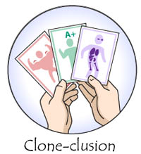
Clone-clusion
There are several __________________ that are brought up by cloning. The logical conclusion to most research done with cloning is the question of cloning people. Cloning of people is currently ___________________ in the United States and many other countries. There are two main applications of cloning that bring up serious _____________ and _______________ questions.
The first main application of cloning is that the technology can be used to create "________________ children." The ability to _____________ specific genetic material you want to and make a child means that people could _______________ make their children. This worries people because of the possible use of the technology to make children to _________________ another person from an _________________, or to make another person to ___________________ organs from, or to take the genetic material of a great athlete. The question is: does the designed child have a right to lead life without the burden of the original purpose they were created for?
What do you think and why?
________________________________________________________________________________________________________________________________________________________________________________________________________________________________________________________________________________________________________________________
The second main application of cloning is that the technology can be used to create "____________ cells." Stem cells are cells that have ________________ decided what they are to become. Stem cells can theoretically become _____________________. This makes stem cells important in ________________ treatment. Stem cells are extracted from an _________________________. A fertilized ____________ will create an embryo. An egg that has had its _________________ removed and replaced by a ______________ cell will create an embryo. This act of removing stem cells, ______________ the embryo from living. Using the nuclear transfer method will create a ______________________ embryo. This designer embryo will have the same cell type as the ______________ nucleus. The question is: will people start making designer embryos to create stem cells that might save them from disease years from now?
What do you think and why?
________________________________________________________________________________________________________________________________________________________________________________________________________________________________________________________________________________________________________________________
Of course, there are many other issues within _______________ here. You might know of several. The way to answer these _____________ and ________________ issues is through discussion, education, and scientific research. That means you need to ______________ with people, ___________________ at school, and maybe even become a __________________ yourself!
The word ‘somatic’ comes from the Latin word for what?
- Cell
- Clone
- Body
- Blood
- Stomach
Gamete means:
- Body cell
- Cloned cell
- Reproductive cell
- Skin cell
- Gamatic cell
How did they determine that dolly was in fact a clone?
- She had a white face
- She had a black face
- She was identical to her birth mother
- Her genetic material was tested to confirm
What is an example of an ethical question?
__________________________________________________________________________________________________________________________________________________________________________________________________________________________________________
What does the term embryo mean? ______________________________________________________________________________
What are designer children?
__________________________________________________________________________________________________________________________________________________________________________________________________________________________________________
What are the applications of stem cells?
__________________________________________________________________________________________________________________________________________________________________________________________________________________________________________

We are now going to watch Netflix Explained – Designer DNA
Fill out this KWL (know, want to know, learned) chart as we watch. Feel free to draw images, write key words, question things being talked about etc.
Know | Want to Know | Learned

