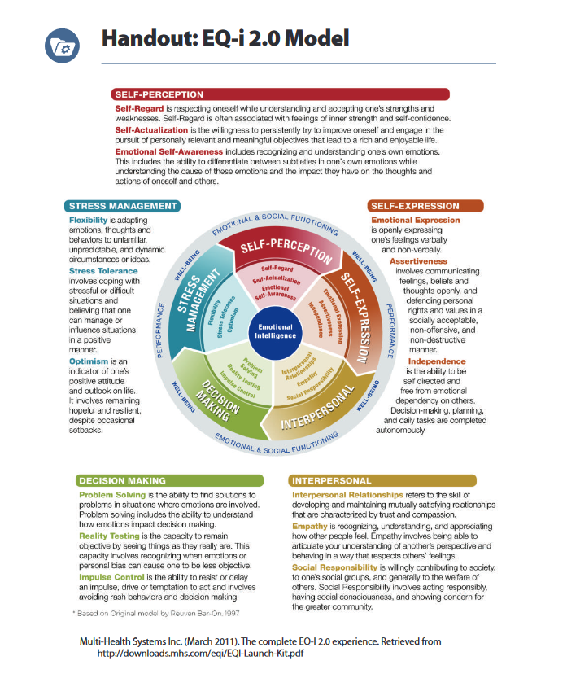
As you go through and listen to me speak throughout the slideshow complete the following work:

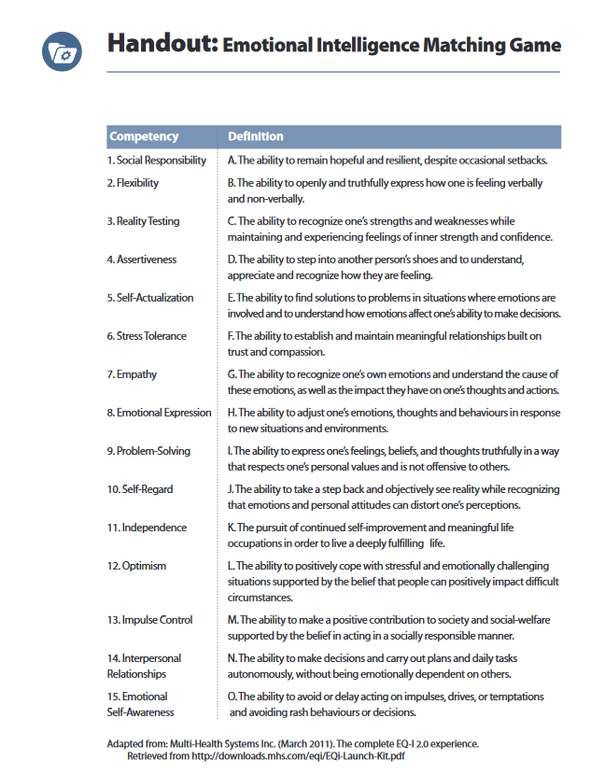

- _____
- _____
- _____
- _____
- _____
- _____
- _____
- _____
- _____
- _____
- _____
- _____
- _____
- _____
- _____

Case Study – Jamie

How could Jamie respond?

Which responses show high emotional intelligence?

Which responses show low emotional intelligence?

Which competency area(s) relate to each response?

Application to Peer Mentoring
How is emotional intelligence relevant and applicable to your role as a Peer Mentor?

Choose three of the EI components that you think will be the most valuable and/or effective in your role as a Peer Mentor.

What is one strategy you will practice to further enhance your strongest EI domain?

What is one strategy you will practice to develop a weaker EI domain?

Emotional intelligence Activities
Watch this talk by Brené Brown: “The Power of Vulnerability – Brené Brown” on The RSA’s YouTube channel (https://www.youtube.com/watch?v=sXSjc-pbXk4, 21:47 minutes long). Note: There are several YouTube clips with similar names; please use this URL and watch this talk for the purpose of this exercise.

Respond to the following questions:
- What is one new idea that you are taking away from this video?

- What did you learn about empathy?

- Brené Brown says that empathic responses never begin with: _________. What phrase does she use? Have you experienced someone responding to you in this way? How did it make you feel?

- Brené Brown says, “Rarely does a response make something better. What makes something better is connection.” How could you apply this philosophy to your role as a peer mentor and to your interactions with a Mentee?

Complete the 16 Personalities Test
(available here: https://www.16personalities.com/free-personality-test)
This test is based on The Big Five Personality Traits, and inspired by the Myers-Briggs Type Indicator and Jung’s Theory of Psychological Traits.
What were the results of your personality test?

Did the results fit with who you are? Give an example or piece of evidence from your life to explain if the result “fit” you, or not.

