Grade 8 Understanding Chemical Reactions

New Vocabulary
English Word | Definition
Chemical Bond | Chemical bond attraction between atoms when electrons are shared, transferred, or pooled
Coefficient | Number placed in front of an element symbol or chemical formula in an equation
Chemical Reaction | Process in which atoms of one or more substances rearrange to form one or more new substances
Chemical Equation | Description of a reaction using element symbols and chemical formulas
Reactant | Starting substance in a chemical reaction
Product | New substance produced by a chemical reaction
Endothermic Reaction | Chemical reactions that absorb thermal energy
Exothermic  Reaction | Chemical reactions that release thermal energy
Activation Energy | Minimum amount of energy needed to start a chemical reaction
Catalyst | Substance that increases the reaction rate by lowering the activation energy of a reaction
Enzyme | Catalyst that speeds up chemical reactions in living cells
Inhibitor | Substance that slows down, or even stops, a chemical reaction

Changes in Matter
Physical Changes
Does not produce a new substance – Water freezing to become Ice – it only changes from a liquid to a solid but the water does not change into a different substance.

Chemical Changes
Substances change into a new substance. The starting substance (Reactant) and the produced substance (Product) have different physical and chemical properties. This is called a chemical reaction – where atoms of one substance rearrange to form a new substance.

Signs of Chemical Reactions
Changes in Properties
Change in color | Formation of Bubbles
Change in smell | Formation of a Precipitate (a solid formed)

Changes in Energy
Warming and Cooling | Production of Light

What happens in chemical reactions?
Atoms rearrange to form new Substances and bonds break and new bonds form. Look at the formation of water molecules in the diagram below. See how the atoms rearranged and where bonds broke and new bonds have formed.
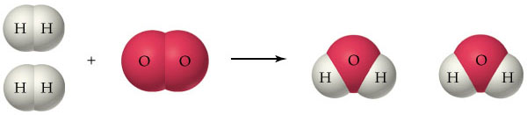

Chemical Equations
A description of a chemical reaction using element symbols and chemical formulas. Element symbols like Cu for copper and O₂ for Oxygen. Chemical Formulas like CO₂ for carbon dioxide and H₂O for Water.

Writing chemical Reactions
The starting substance in a chemical reaction is a REACTANT where the produced substances are PRODUCTS. Chemical formulas are used to describe the reactants and products

Reactants are written on the left Products are written on the right
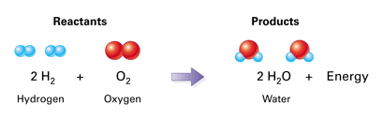

Conservation of Mass in Chemical Reactions
The law of conservation of mass states that the total mass of the reactants before the chemical reaction is the same as the total mass of the products after the chemical reaction.
This is because atoms are not destroyed or created. All atoms at the start of the chemical reaction are present at the end of the chemical reaction and therefore the mass will be exactly the same.

Balancing Chemical Equations
Like discussed before the amount of atoms in the reactants has to be the same as the amount of atoms in the products at the end of a chemical reaction. To achieve this we have to balance the equation to make sure it is the same.
You add coefficients in front of an element or compound
- Write the unbalanced equation
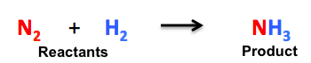
- Count atoms of each element in the reactants.
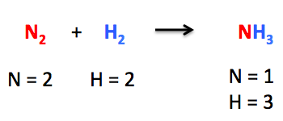
- Add Coefficients to balance the atoms
  - Pick an element that is not balanced and ad a coefficient in front of the reactant or product
  - Recount the atoms on both sides
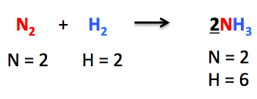
  - Repeat until balanced
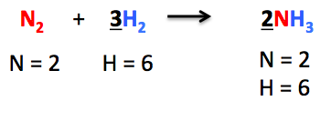
- Write the balanced chemical reaction including the coefficients.
N₂ + 3H₂ 2NH₃

Types of Chemical Reactions
- Synthesis
A type of chemical reaction in which two or more substances combine and form one compound
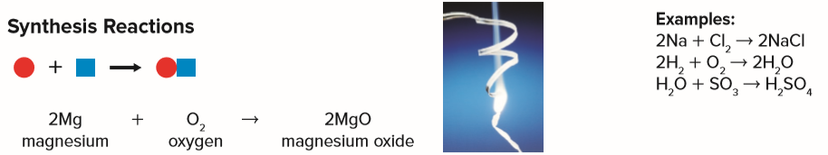

- Decomposition
One compound breaks down and forms two or more substances.
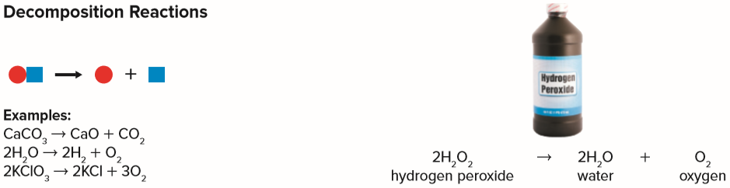

- Replacement
An atom or group of atoms replaces part of a compound.
- Single replacement reaction, one element replaces another element in a compound.
- Double-replacement reaction, the negative ions in two compounds switch places, forming two new compounds.
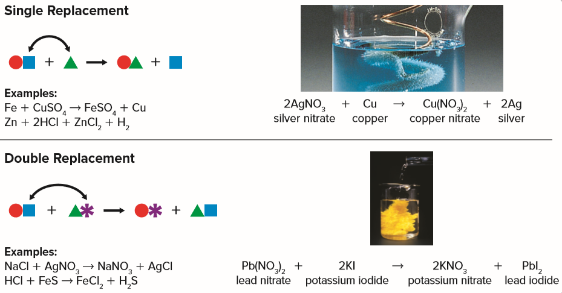
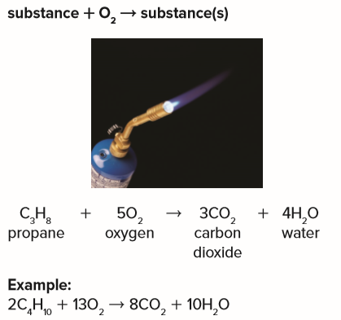
- Combustion
A chemical reaction in which a substance combines with oxygen and releases energy.

Chemical Energy in Bonds
When chemical reaction occur bonds in the reactant break and new bonds form, these bonds contain chemical energy
Breaking a bond requires energy
Forming a bond release energy

Endothermic Reactions – Energy Absorbed
Chemical reactions that absorb thermal energy are Endothermic Reactions
Reactants + Thermal Energy Products

Exothermic Reactions – Energy Released
Chemical reactions that release thermal energy are Exothermic Reactions
Reactants Products + Thermal Energy

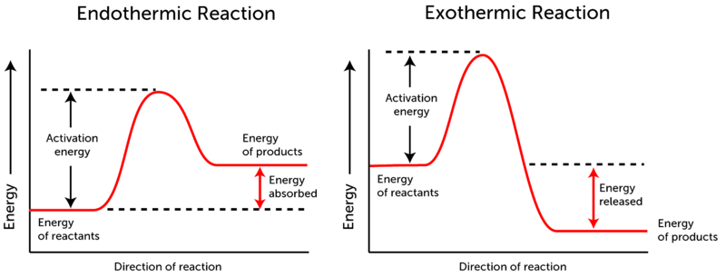

Activation Energy
Some chemical reactions do not just start by themselves, they require energy to start the breaking of bonds and this is called Activation Energy – the minimum amount of energy needed to start a chemical reaction.

Factors that affect Reaction Rates
