WORKSAFE ORIENTATION
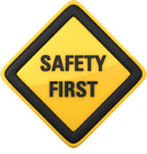
- WHY FOCUS ON YOUNG WORKERS?

Go to the following website and view the WorksafeBC YouTube video:

https://youtu.be/ZulxWEvQd_I

(Why Focus on Young Workers? Alex's Story)

Why is there such a focus on your worker safety?

- WHAT ARE MY RIGHTS AND RESPONSIBILITIES IN TERMS OF SAFETY?

Go to the following website and view the WorksafeBC YouTube video:

https://youtu.be/LkeQieO5THw

(Young Workers: Your Rights and Responsibilities)

- What are your 3 basic rights?

- WHAT ARE THE EMPLOYER’S RESPONSIBILITIES/DUTIES IN TERMS OF SAFETY?

Go to the following website and view the WorksafeBC YouTube video:

https://youtu.be/cnMrFygloHY

(Hiring Young Workers: What's Required by the OHS Regulation?)

- What are the general duties of employers in terms of safety?

The Young and New Worker Regulations:

4. What is a young worker?

5. What is a new worker?

6. What are some topics an employer must consider when providing orientation & training as per the Young and New Worker Regulations?

- WHAT ARE YOUR TOP 7 HAZARDS?

Go to the following WorksafeBC website (or see next page):

https://www.worksafebc.com/en/health-safety/education-training-certification/young-new-worker/know-hazards

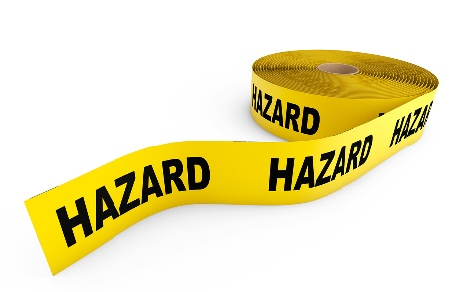
7. What are the top 7 hazards for young workers?

1.

2.

3.

4.

5.

6.

7.

8. For the work experience placement that you are interested in, which of the top 7 dangers might you face?

9. What will you do to prevent injury on your work experience placement? List 3 things:

10. Watch the following: https://goo.gl/ppclC0 Young Worker Safety by WCB NS. (This is produced for Nova Scotia residents by the Workers Compensation Board of Nova Scotia. However, the rules, steps and idea presented are applicable in BC.)

What is 1 key point, in terms of your safety, that you learned from this video?

WORKPLACE RIGHTS AND RESPONSIBILITIES & HAZARDS

Your Rights
- The right to know about hazards in the workplace.
- The right to participate in health and safety activities in the workplace.
- The right to refuse unsafe work.*
How to REFUSE unsafe Work:
You have the right to refuse work if you (a) have a reasonable cause and (b) follow all procedures in the Regulation. If you do refuse to do work you consider unsafe, you should consider the following steps:
- You must discuss the situation with your supervisor or employer.
- If the matter is not resolved, then a worker representative must be involved.
- If the matter is still unresolved, a Worksafe BC field officer is called by both worker and management representatives.
- While the matter is being resolved, you will be temporarily reassigned to another job.

If you feel you must refuse work, be sure to follow the procedures in the regulation and any other polices that the employer may have. Don’t just stop work and go home! If you don’t follow the procedures, you may be subject to disciplinary action by your employer.

Your Responsibilities
As a worker, you play an important role in making sure you — and your fellow workers — stay healthy and safe on the job. As a worker, you must:
- Be alert to hazards. Report them immediately to your supervisor or employer.
- Follow safe work procedures and act safely in the workplace at all times.
- Use the protective clothing, devices, and equipment provided. Be sure to wear them properly.
- Co-operate with joint occupational health and safety committees, worker health and safety representatives, WorkSafeBC prevention officers, and anybody with health and safety duties.
- Get treatment quickly should an injury happen on the job and tell the health care provider that the injury is work-related.
- Follow the treatment advice of health care providers.
- Return to work safely after an injury by modifying your duties and not immediately starting with your full, regular responsibilities.
- Never work under the influence of alcohol, drugs or any other substance, or if you're overly tired.
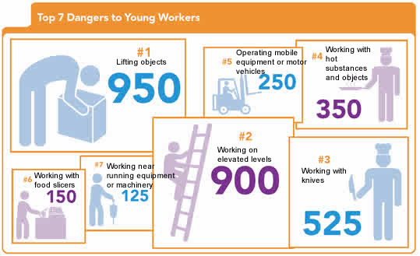
TOP SEVEN HAZARDS TO YOUNG WORKERS:
1. Lifting objects — overexertion causing sprains, strains, tears
2. Working on elevated levels — sprains, strains, tears, and fractures
3. Working with knives — cuts and lacerations
4. Working with hot substances/objects — burns
5. Using mobile equipment or motor vehicles — sprains, strains, tears, and fractures
6. Working with food slicers — cuts and lacerations
7. Working near running equipment or machinery — cuts, lacerations, and fractures

